One-Way ANOVA – Example 1 (Types of Music)

An experimenter is interested in the effect of music on memory for words. The data are shown below. Each score represents the number of words recalled. Analyze the data using the appropriate statistical tests.

Step 1. State your hypotheses.
a. Research hypotheses
H_{A}:

H₀:

b. Statistical hypotheses
H_{A}:

H₀:

Step 2. Set the significance level ➔ α = .05 Determine F_{crit}. F_{crit} = _________
df_{between} = ________ df_{within} = ________

df_{between} = k – 1 df_{within} = N_{tot} – k df_{tot} = N_{tot} – 1 df_{tot} = df_{between} + df_{within}

Step 3. Select and compute the appropriate statistic and then complete the source table.
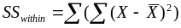
Country  X₁ | Classical  X₂ | Blues  X₃
3 | 5 | 9
2 | 3 | 8
5 | 5 | 9
2 | 2 | 7
2 |  | 9
ΣX₁ = | ΣX₂ = | ΣX₃ =
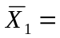 | 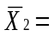 | 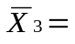

Country  X₁ | X₁ - M_{Tot} | (X₁ – M_{Tot})²
3
2
5
2
2
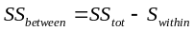

Classical  X₂ | X₂ - M_{Tot} | (X₂ – M_{Tot})²
5
3
5
2

Blues  X₃ | X₃ - M_{Tot} | (X₃ – M_{Tot})²
9
8
9
7
9

MS_{between} = SS_{between} / df_{between} MS_{within} = SS_{within} / df_{within} 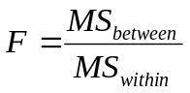

Source | SS | df | MS | F
Between
Within
Total

Step 4. Make a decision. Determine whether the value of the test statistic is in the critical region. Draw a picture. Label F_{crit} and F_{obt}.
Is F_{obt} in the critical region? ___________
Should you reject or retain the H₀? __________

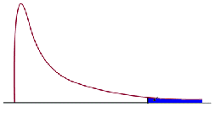

Step 5. Report the statistical results.

Step 6. Write a conclusion.

Step 7. If appropriate, compute η² and write a conclusion.
